Git Commands

1. git init : Makes a normal folder into a Git project so Git can save and track your code changes.

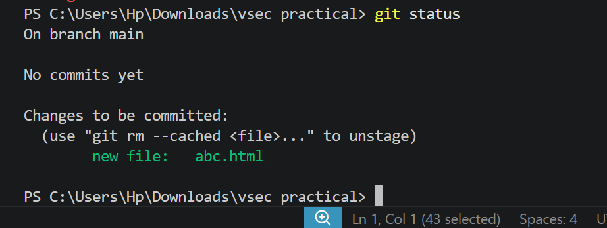
2. git status: Shows the current status of your Git repository, such as which files are new, modified, deleted, or ready to be committed.

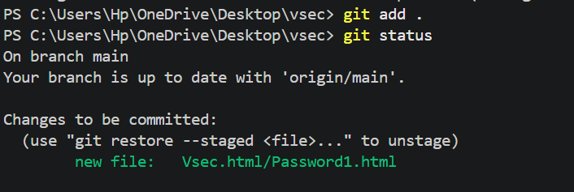
3. git add . : Adds all new and changed files to Git, making them ready to be saved in the next commit.
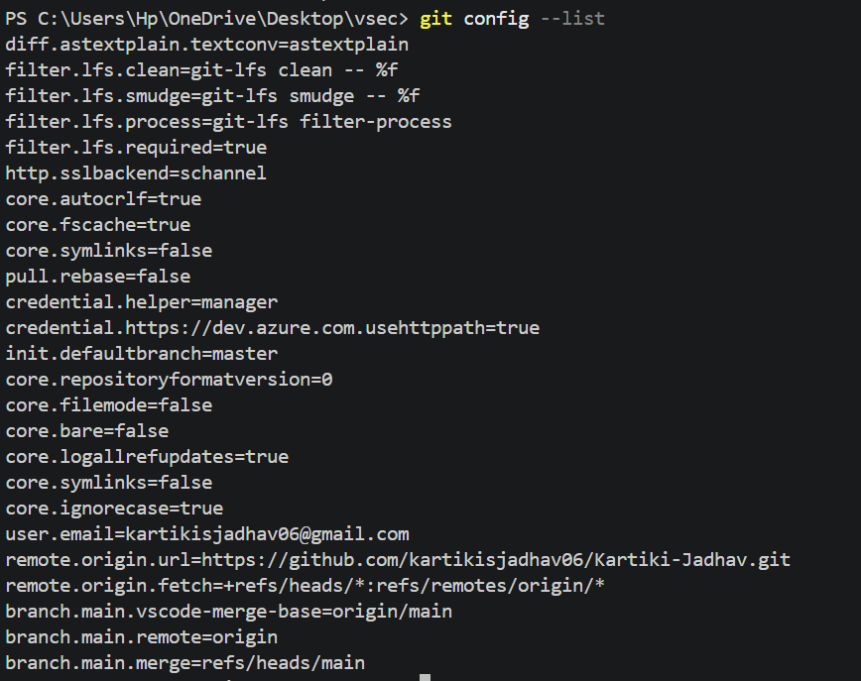
4. git config --list : Displays your Git configuration settings, such as your username, email, default editor, and other Git settings.

5. git config user.email "your_email" : Sets the email address that Git will use to identify you in your commits.
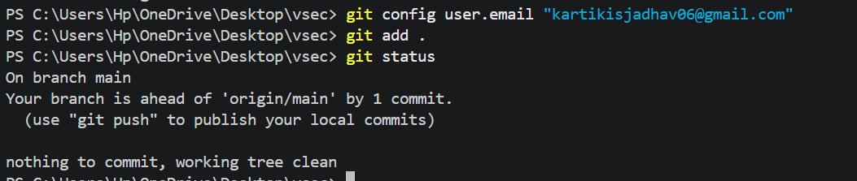

6. git remote add origin https://github.com/USERNAME/VSEC_ASS.git : Connects your local Git project to a GitHub repository so you can push and pull code.

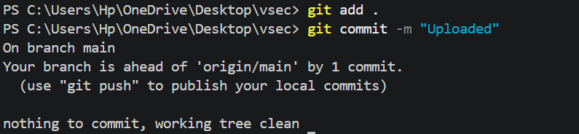
7. git commit -m "your Message": Saves the added changes as a commit with the message "uploaded".

8. git branch -M main : Renames your current branch to main.
9. git push -u origin main : Uploads your project to the GitHub main branch and remembers the connection for future pushes.
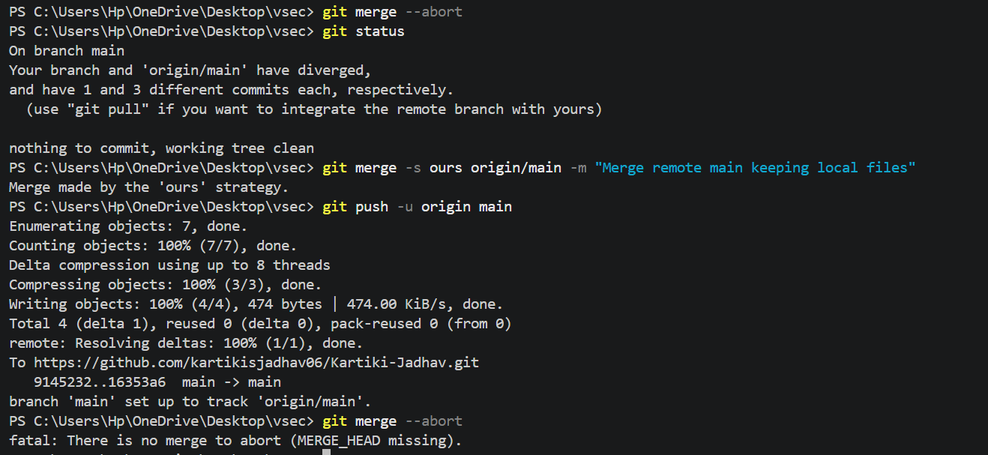
10. git push : Uploads your saved changes (commits) to GitHub.

